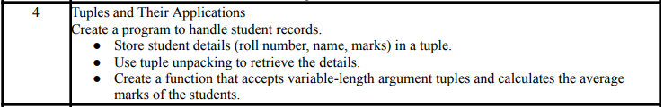
COMMAND:
“”” Tuples and Their Applications Create a program to handle student records.
● Store student details (roll number, name, marks) in a tuple.
● Use tuple unpacking to retrieve the details.
● Create a function that accepts variable-length argument tuples and calculates the average marks of the students. ”””

# Function to calculate average marks
def average_marks(*students):
total = 0
for stu in students:
total += stu[2] # marks are at index 2
return total / len(students)

# Taking number of students
n = int(input("Enter number of students: "))

# Empty list to store all student tuples
student_list = []

# Taking details for n students
for i in range(n):
print(f"\nEnter details for Student {i+1}:")
roll = int(input("Roll No: "))
name = input("Name: ")
marks = int(input("Marks: "))
student_list.append((roll, name, marks)) # Tuple packing

# Tuple unpacking example (first student)
roll, name, marks = student_list[0]
print("\nFirst Student Details:")
print("Roll No:", roll)
print("Name:", name)
print("Marks:", marks)

# Calculate and display average marks
avg = average_marks(*student_list) # unpack list into function
print("\nAverage Marks of all students:", avg)

OUTPUT:
